**Kensington-Rockville Branch Program**

**Hung Liu’s Portraits of Promised Lands:**

**An Inspirational Story**

Via Zoom

Saturday, February **19**, 2022, 10:30 a.m. [note date change]

As Covid confinement grows ever more stressful and stale, new research suggests that viewing art seems to improve people’s mental outlook and 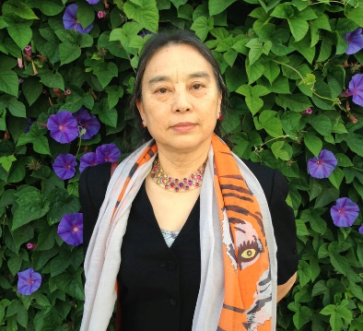health. So perhaps it’s a good time to lift our spirits with a look at the art and life story of an amazing woman artist.

Learning about the unusual and powerful portraiture of Hung Liu, a Chinese-American woman, serves AAUW’s mission to promote diversity and inclusion. What’s more, that was her mission, too. She sought and empathetically portrayed people who have been forgotten or marginalized as well as those she personally loved. Hung Liu’s work might even be a helpful nudge as we seek to make a more direct difference in our troubled world.

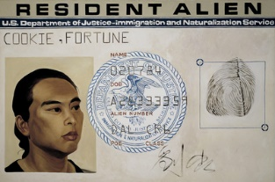Dian Belanger, historian and thirteen-year docent at the National Portrait Gallery, where this exhibit will be shown until May 30, 2022, offers this PowerPoint presentation.

Please join us on Zoom, link forthcoming, and invite your friends.

**President’s Message**

We have several things going on in our branch and I hope you will consider joining in one or more of our activities if you have not already done so. The newsletter outlines those groups. Contact the leaders for more information if you have questions.

Maryland State AAUW has issued a challenge to our state members and branches. We support the Women of Distinction event at the annual National College Women’s Student Leadership conference by our contributions. The Board members are challenged to meet 100% participation and the branch members are asked to reach 50% participation. What is important for this challenge is not the size of your contribution, but that you make one. Ella Iams has laid out the process and I invite you to follow it.

Last month, Diane Bailey spoke to us about ways in which we can support incarcerated women. Several members joined in a conversation about a small but impactful way in which we could bring branch members together. In addition to supporting women in our community, we hope that branch members will be part of the work we commit to. If you are interested in finding out more, please let me know.

Please note that we will meet on a different day this month: Saturday, February 19th. Look forward to seeing you there.

Take good care!

Jeri Rhodes President

**AAUW Maryland Challenge**

To raise funds for the AAUW Maryland Woman of Distinction Honoree, Dr. Pat Stocker, AAUW Maryland is challenging each branch to have **all its Board members and fifty percent of Branch members** contribute to the Maryland Woman of Distinction Fund, **Fund 4355.**  Branches meeting the goal will be recognized at the AAUW Summer Conference.

AAUW Maryland is making this challenge to provide Branch members a larger sense of belonging to AAUW beyond their Branch. By donating to the Women of Distinction Fund each member is participating in an Association and Maryland State AAUW Project. The Association project is the sponsorship of the National Conference for College Women Student Leaders (NCCWSL) which takes place in early June. The State project is raising the sponsorship money of $20,000 to honor a Maryland Woman of Distinction. By achieving our $20,000 goal, a platinum sponsorship of the Women of Distinction event, Pat Stocker will address the NCCWSL conference attendees at the Women of Distinction event at the University of Maryland, College Park, as the AAUW Maryland Woman of Distinction.

Please give generously and help Maryland AAUW reach our goal.

To donate online: Go to [www.aauw.org](http://www.aauw.org) and click **Donate** button at top right. Scroll to very bottom and click **Give to Support SCCWSL** (tiny print). **Click second box: Maryland Woman of Distinction (NCCWSL) Fund [4355].** Choose $ amount and whether one time or monthly payment. Click **Donate Now** to provide ID and payment card information.

To donate by check: Make check payable to AAUW and indicate Fund 4355 Maryland Woman of Distinction (NCCWSL) Fund on memo line. Mail to AAUW 1301 L Street, NW Suite 1000, Washington, DC 20005. The **donation deadline is March 31, 2022.**

After you have made your donation, please notify Ella Iams by email [ella.w.iams@gmail.com](mailto:ella.w.iams@gmail.com) so I can keep track of the number of donors from our Branch.

Ella Iams

**Le Beret Rouge**

Le Groupe Français has been meeting for over twenty-five years. Currently eight members meet monthly via ZOOM to talk and read French. At our recent February meeting we revived a favorite pre-pandemic activity – eating. During the pre-pandemic in-person gatherings, we had enjoyed a variety of cuisine including cheese platters, French soups, international and French desserts, as well as several other pot-luck meals.

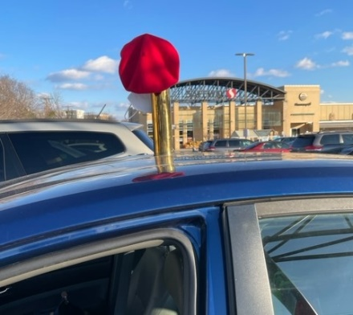For the virtual culinary get-together, Monique Briend- Walker prepared a veal stew, a family favorite from her native province of Brittany. There were also deviled eggs, brioche, macarons and cranberry-nut rum cake. The meal distribution took place at the Kensington Safeway with a meeting at the blue car with the red beret perched on top of a World War I shell. We all enjoyed a delicious dinner via ZOOM, but the highlight was the opportunity to see each other in person, albeit for only a few minutes with masks on our faces.

Ruth Spivack

**Deadline for the March Newsletter is February 20.**

**Newsletter Editor Circulation Editor**

Margery Sullivan Ruth Spivack

[msullivan@niaid.nih.gov](mailto:msullivan@niaid.nih.gov) [raspivack@gmail.com](mailto:raspivack@gmail.com)

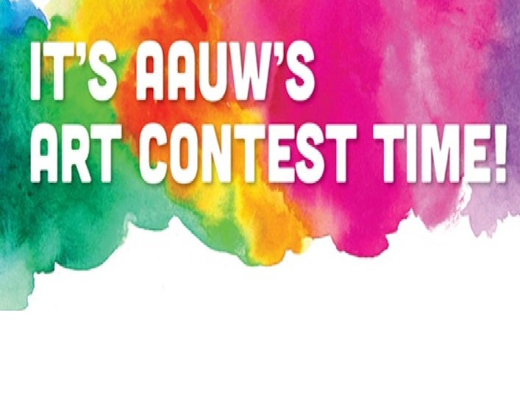

**Calling AAUW Artists!**

The following invitation/reminder comes from Tremayne Parquet, Deputy Director of Advancement & Partnerships at AAUW:

Was this the year you finally found time to devote to a painting or art project? If so, you’re in luck! AAUW’s 13th annual art contest is under way, and you are invited to **submit a high-resolution image** of your original painting, photograph, sculpture, collage, or other artwork. We know from past years’ entries that there is a lot of talent out there! Your work could be among the winning entries!

AAUW is accepting submissions through January 31, 2022. Art related to any topic is acceptable, but AAUW encourages you to consider works that speak to AAUW’s mission of advancing equity for women and girls.

Starting in February, AAUW members will select their favorite entries via ranked-choice voting. The winners will be featured on a collection of notecards sent to all members this spring. The back of each card will include the winning artist’s biography, a fact about AAUW, and a highlight of the artist’s branch affiliation.

For more information on submitting artwork or to peruse last year’s art gallery, visit the AAUW website’s **AAUW Art Contest** page. It would be great to see your work recognized.

**Take part in the Women’s Legislative Briefing, Sunday, January 30th – 12:30 – 5.**

**2022 is the 42nd anniversary of the Women’s Legislative Briefing. Due to COVID, this year’s meeting will be held virtually.**

The purpose of the well-attended briefing is to provide information on legislative issues of concern to women and families, including bills that will be introduced in the upcoming sessions of the Maryland General Assembly and U.S. Congress. Local and state officials are invited to attend the briefing.

The Keynote Speaker is Melanie L. Campbell, President/CEO, The Nation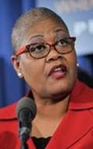al Coalition on Black Civic Participation

The program Schedule:

12:30 p.m. -1:00 p.m. - Welcome and Introductions

1:00 p.m. - 1:55 p.m. - Keynote Address

2:00 p.m. - 2:55 p.m. - Breakout Session One

**Topics: Voting to Protect and Voting for Access**

3:00 p.m. - 3:55pm - Breakout Session Two

**Topics: Voting for Your Health and Educating the Vote**

4:00 p.m.- 5:00 p.m. Networking Reception and Closing

Again, this year: special seminars will be offered for students in grades 6 - 12 through our Emerging Leaders track.

**Cost** $22 until January 28th. January 28-30th $30. $5 Students/Emerging Leaders

Register on line at: <https://www.eventbrite.com/e/2022-womens-legislative-briefing-registration-211113214307>Register on line at: [https://www.eventbrite.com/e/2022-womens-legislative-](https://www.eventbrite.com/e/2022-womens-legislative-briefing-registration-211113214307)

**Interest Groups**

**Literature Group**

Margaret Schweitzer [margaretfschweitzer@gmail.com](mailto:margaretfschweitzer@gmail.com)

The literature group will meet on Tuesday, February 22 at

[1p.m. to](http://1p.m.to) 3 p.m. on Zoom.    We will be discussing *" Before*

*We Were Yours" by Lisa Wingate.*

This book tells the story of children taken from their homes in Tennessee in the 1930s.  It is a fictional story based on real situations which existed in those times and in the present. Margaret Schweitzer will be leading the discussion.

The Zoom link will be sent prior to the meeting.

.

**Great Decisions**

Anita Rosen [anitarosen123@gmail.com](mailto:anitarosen123@gmail.com)

Bobbe Mintz [Bobbeandherb@comcast.net](mailto:Bobbeandherb@comcast.net)

The February Meeting will be held on Zoom Friday, February 18th at 2:00 pm.

We will be going out of order and discussing ***Chapter 3, Putin’s Russia***

A Zoom URL will be sent prior to the meeting. It there is a video viewing, a URL with viewing times

will be sent, too.

For Information contact: Anita or Bobbe

**Le Groupe Français**

Ruth Spivack [**raspivack@gmail.com**](mailto:raspivack@gmail.com)

Le Groupe Français will meet February 21 at 5 :30 p.m. via ZOOM

The Zoom link will be sent prior to the meeting.

**.**

**Upcoming Events**

January 30 Women’s Legislative Briefing 12:30 Zoom

February 12, 2022, Bethesda Chevy Chase AAUW Branch Meeting Zoom

**Perspectives on Women in Afghanistan**

Nadia Hashimi, author, *Sparks Like Stars*

**AAUW advances equity for women and girls through advocacy, education, philanthropy, and research.**

***The Afternoon Literature Group***

Judy Burr [judyb429@verizon.net](mailto:judyb429@verizon.net)

October 17, 2017, the group will be discussing My Brilliant Friend by Elena Ferrante

**AAUW Vision Statement: *AAUW will be a powerful advocate and visible leader in equity and education through research, philanthropy, and measurable change in critical areas impacting the lives of women and girls.***

**AAUW has been empowering women as individuals and as a community since 1881. For more than 135 years, we have worked together as a national grassroots organization to improve the lives of millions of women and their families.**

**In principle and in practice, AAUW values and seeks and inclusive membership, workforce, leadership team, and board of directors. There shall be no barriers to full participation in this organization based on age, disability, ethnicity, gender identity, geographical location, national origin, race, religious beliefs, sexual orientation, and socioeconomic status.**

**AAUW Kensington-Rockville Branch**

**6540 Wiscasset Rd**

**Bethesda, MD 20816-2113**