Kensington-Rockville Branch Program
Glenstone Museum Visit
12100 Glen Road, Potomac, MD

Saturday, April 9, 2022, 12 noon

[We MUST honor this timed, ticketed arrival but may stay or leave at will until the 5:00 closing.]

Glenstone Museum, in its own words, “seamlessly integrates, art, architecture, and nature into a serene and contemplative environment.”

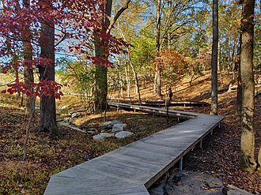
We’re overdue for a Kensington-Rockville Branch field trip, and it’s hard to imagine a finer setting to savor Spring than this privately created gem in nearby Potomac. Glenstone began as Emily & Mitch Rales collected post-World War II art, in “pursuit of iconic works that have changed the way we think about the art of our time.” Today the beautiful surroundings and outdoor sculptures are as inviting as the extensive Pavilions and original Gallery.

Admission is free. As of now, visitor masking is optional. There are no guided tours or descriptive text. We are invited to interpret Glenstone in our own way. Maps and minimal signage provide orientation, and uniformed volunteers welcome questions or discussions. The site is expansive with varying elevations; wear comfortable shoes.

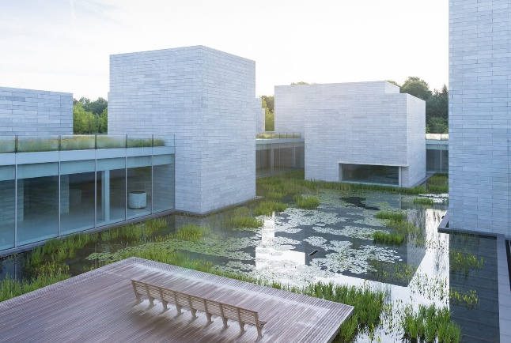
Food, seasonal and locally sourced, is available at the on-site café, with indoor and outdoor dining.

Let’s carpool and think positive weather thoughts. Tickets will be distributed on site.

Dian Belanger
Program Vice President
dobelanger@comcast.net

New AAUW Membership Accounts

If you haven’t already done so, members must set up a new membership account and password on the AAUW national website, renamed the “AAUW Community Hub” which is a members’ personal portal into AAUW. (Available at https://www.aauw.org/new-systems-update/)
You’ll need an account to renew your membership, donate and update branch activities. There are tutorials available on line at and on March 31, there will be an in-depth training webinar. (Available at https://us02web.zoom.us/webinar/register/WN_OuKLQJC2SBGCWZ4gIYsMyA?emci /register)

President’s Message

In early March, nineteen members of our branch met at Farmsook Happiness, a Thai restaurant in Kings Farm. It was a great opportunity to see each other in person, enjoy a meal and talk about projects done by our branches – past and future. Knowing that not everyone could attend due to health concerns and other reasons, I was so grateful for Dian’s leadership in getting us together. A long awaited – and needed – face to face opportunity.
We are planning a field trip in April. More details are included in this newsletter. I hope you’ll be able to join us. Our Annual Meeting is a luncheon in May, during which we will install next year’s officers. I hope you can participate with us at this meeting.
The world changes daily and I must admit that I am weary of reading how so many writers dealt with the reality of the last few years. But every once in a while, an article does make me sit up! The Post had an article by a writer who has learned to appreciate cold showers – and the invigoration that follows. I am curious, but not curious enough to try it. I wonder what other interesting experiences we have had that have helped us get through this new way of living.
Look forward to seeing you all again, in April or in May.

Jeri Rhodes

AAUW Maryland Challenge for Woman of Distinction

Dr. Pat Stocker has been chosen by AAUW Maryland to be this year’s Maryland’s Woman of Distinction at the National Conference of College Women Students (NCCWSL). To achieve this Maryland must reach the Platinum Donor Level raising $20,000 by March 31, 2022.

AAUW Maryland is challenging each branch to have all its Board members and fifty percent of Branch members contribute to the Maryland Woman of Distinction Fund, Fund 4355. Branches meeting the goal will be recognized at the AAUW Summer Conference.

AAUW Maryland Challenge to Branches

Kensington-Rockville Branch members, remember to contribute to the Maryland Woman of Distinction (NCCW) Fund by March 30. If 100 % of our Board Members and 50 % of our Branch members donate, the Branch will be recognized at the Summer Conference.
Please give generously and help Maryland AAUW reach our goal.

To donate online: Go to www.aauw.org and click Donate button at top right. Scroll to very bottom and click Give to Support SCCWSL (tiny print). Click second box: Maryland Woman of Distinction (NCCWSL) Fund [4355]. Choose $ amount and whether one time or monthly payment. Click Donate Now to provide ID and payment card information.

To donate by check: Make check payable to AAUW and indicate Fund 4355 Maryland Woman of Distinction (NCCWSL) Fund on memo line. Mail to AAUW 1301 L Street, NW Suite 1000, Washington, DC 20005. The donation deadline was March 31, 2022, funds will still be accepted.

After you have made your donation, please notify Ella Iams by email ella.w.iams@gmail.com so I can keep track of the number of donors from our Branch.

Ella Iams

Interest Groups
Le Groupe Français
Ruth Spivack raspivack@gmail.com
Le Groupe Français will meet on April 11 at 5:30 p.m. on ZOOM.
Contact Ruth (raspivack@gmail.com) for more information.

.

Great Decisions

Anita Rosen anitarosen123@gmail.com
Bobbe Mintz Bobbeandherb@comcast.net

The April Meeting will be held on Zoom Friday, April 22 at 2:00 pm. NOTE Change of Date
We will be discussing Chapter 2, The Renewed Climate Change Agenda

A Zoom URL will be sent prior to the meeting. Also, a video Zoom presentation URL, with viewing times will be sent,

For Information contact: Anita or Bobbe

Literature Group

Margaret Schweitzer margaretfschweitzer@gmail.com

The Literature group will meet at 1 p.m. On Tuesday April 19th via Google. We will be discussing "Educated" by Tara Westover. Ella Iams will be leading the discussion.

This memoir is about a young woman, raised by a survivalist family and kept out of school. She somehow manages to escape and earns a PhD degree from Cambridge University.

It is time to suggest books for the 2022-2023 year. Send your suggestions to margaretfschweitzer@gmail.com.

The Zoom link will be sent prior to the meeting. If you want to participate
and are not on my list, please contact me.

Newsletter Editor Circulation Editor
Margery Sullivan Ruth Spivack
msullivan@niaid.nih.gov raspivack@gmail.com

Upcoming Events
See attachment of Gaithersburg AAUW events

Deadline for the April Newsletter is April 20.

AAUW advances equity for women and girls through advocacy, education, philanthropy, and research.
The Afternoon Literature Group
Judy Burr judyb429@verizon.net

October 17, 2017, the group will be discussing My Brilliant Friend by Elena Ferrante

AAUW Vision Statement: AAUW will be a powerful advocate and visible leader in equity and education through research, philanthropy, and measurable change in critical areas impacting the lives of women and girls.

AAUW has been empowering women as individuals and as a community since 1881. For more than 135 years, we have worked together as a national grassroots organization to improve the lives of millions of women and their families.

In principle and in practice, AAUW values and seeks and inclusive membership, workforce, leadership team, and board of directors. There shall be no barriers to full participation in this organization based on age, disability, ethnicity, gender identity, geographical location, national origin, race, religious beliefs, sexual orientation, and socioeconomic status.

AAUW Kensington-Rockville Branch
6540 Wiscasset Rd
Bethesda, MD 20816-2113

