AAUW Kensington-Rockville Branch

First Meet and Greet of the New Program Year!

Ingleside at King Farm - Derwood Room
Saturday, September 9, 2023, 10:30am
1615 Piccard Drive or 701 King Farm Boulevard, Rockville

Let’s enjoy a chance to meet and greet new members and long-time members, catch up and have a chance to learn new things about each other. We will be sharing some exciting plans and ideas for the coming year as well. We have invited input and material from organizations serving women in our state and county and will be getting an update from State—all chances to update ourselves about the status of and issues related to women, and possible ways to get involved as branch projects.
Refreshments will be served. And we look forward to seeing you, and your special guest!

Anita Rosen CoVP Program
anitarosen123@gmail.com
Map is attached

Presidents’ Message
Welcome, or Welcome Back AAUW Kensington-Rockville begins our new year on Saturday, 9 September 2023, 10:30am in Ingleside’s Derwood Room. We can’t wait to see you again after summer “recess” and are excited about possibilities for 2023-24. Anita and Bobbie, our program vice presidents, are planning, with your input, a varied and engaging year of learning, doing, making a difference, and having fun.
It’s 100 years! since suffragist icon Alice Paul drafted the Equal Rights Amendment and brought it to the attention of Congress. It’s finally been fully ratified but still not officially added to the Constitution as the 28th Amendment. AAUW Maryland president and KR member, Tracy Lantz will report on her attendance at the 175th anniversary of the first suffrage gathering in Seneca Falls, which highlighted a centennial push for the ERA. We’re learning that young women are passionately advocating to get the job done. Yay! But they need help.
AAUW Maryland is seeking a host branch for our 2024 state convention, likely in April. While Kensington-Rockville hosted the 2022 summer conference, at Ingleside, our branch has not arranged a spring convention, a larger undertaking, in some years. We obviously have a beautiful, suitable, convenient venue to offer, and plenty of skills and talents among us to make it happen. We’ve made no promises but will discuss together in September. Be thinking of how you might like to be involved.
Do come and please invite your friends and neighbors to join us
Dian Belanger and Maritsa George, Co-Presidents

Kensington-Rockville Leadership Roster

Co-Presidents Dian Belanger dobelanger@comcast.net
Maritsa George maritsageo@verizon.net

Co-Program Vice Anita Rosen anitarosen123@gmail.com
Presidents Bobbe Mintz bobbeandherb@comcast.net

Membership Ruth Spivack raspivack@gmail.com
Vice President

Co-Treasurers Joyce Graf joyce@regraf.com
Ella Iams ella.w.iams@gmail.com
Secretary

Public Policy
Chair

Newsletter Margery Sullivan msullivan@niaid.nih.gov
Editor

Social Media Yvonne Simms ylsimms@gmail.com
Editor

Montgomery College Janet Crampton janet.crampton@wap.org
Liaison

NCCWSL 2023: Success!

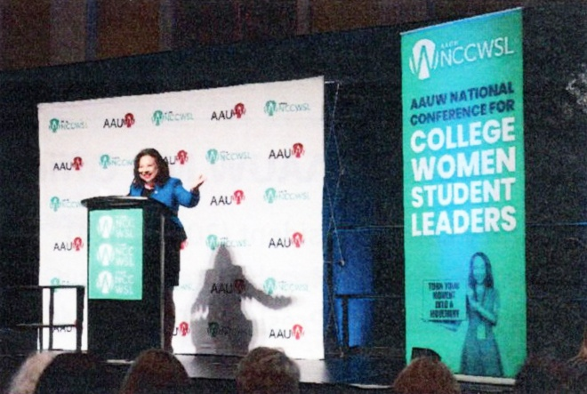
When you hear “Nick whistle,” know it to mean AAUW’s annual National Conference for College Women Student Leaders. Its University of Maryland College Park venue has made NCCWSL a relevant, rewarding fundraising project for our state organization. We have raised $20,000 annually since 2011, making us a Platinum Sponsor of the conference’s highlight, the Women of Distinction awards evening.
Maryland Secretary of State Susan Lee addressing NCCWSL

After one cancellation and two virtual events thanks to Covid, we were gratified that this major program was once again held in person in 2023. Hundreds of young college women leaders from all over the country were inspired by (and later thrilled to meet up close) five diverse national Women of Distinction, whose professional stories and advice showcased their varied ways to combat structural, educational, health, and workplace inequity; improve women’s financial literacy; and celebrate women’s national success in news media.

AAUW Maryland’s own Woman of Distinction, a reward for our collective generosity, was Maryland Secretary of State, and former state senator, Susan Lee, whose advocacy for women we have long admired. She gave a rousing peptalk for young women’s political involvement.

AAUW Marylanders present were thanked and praised numerous times from the stage and later by many enthusiastic students, some of whom specifically inquired about becoming members. Yes!
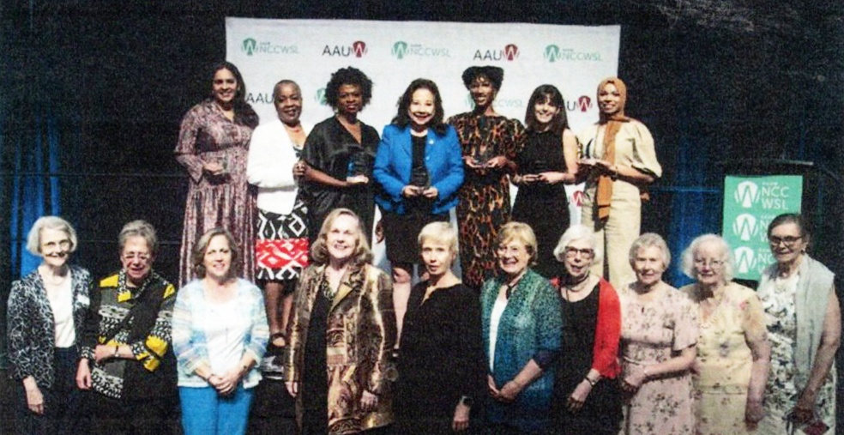
Here we are, Maryland AAUW members invited to be photographed with the Women of Distinction, along with AAUW CEO Gloria Blackwell. Anita Rosen, Margie Sullivan, and Dian Belanger represented the Kensington-Rockville Branch.
AAUW Archives Corps Needs YOU!
Do you enjoy discovering hidden treasures? Are you curious about AAUW’s amazing past? Would you like to make a significant contribution with no ongoing advance preparing?
If so, please join other dedicated member volunteers from the DMV area who comprise the AAUW Archives Corps. We meet on the 4th Monday of alternate months at our national office at 1310 L Street NW, Washington, DC, 10:00a-2:00p. Training is provided so you can process and preserve historic records that, thankfully, have been saved and stored. Our important efforts make them usable and accessible to present and future researchers.
Yes, much of what we do is scut work: remove staples, provide chronological (or other logical) order, cull duplicates, transfer organized records to acid-free folders. But what a thrill it is to uncover something awesome, unusual, or long forgotten. My favorite find: A member/leader bequeathed to AAUW a Montana gold mine!
Please contact Dian Belanger, dobelanger@comcast.net

The AAUW Capitol Hill Lobby Corps Seeks You!
Do you care if the now-approved Equal Rights Amendment gets added to the Constitution as the 28th Amendment?
Is it right that over half a century after pay discrimination became illegal in the United States, women working full time are still paid 83 cents to every dollar earned by men?
Why are we last among developed nations to provide paid family and medical leave for all?
If you are feeling called to do something positive, consider joining the AAUW Lobby Corps, which has actively advocated on Capitol Hill since 1975. Member volunteers, well trained and briefed by AAUW public policy staff, visit assigned congressional offices, in pairs, to promote nonpartisan progress toward a more just nation.
Ramping up after the Covid shutdown, the Lobby Corps will work only one morning per month—on September 21, October 19, and November 16 upcoming. December and 2024 dates are yet to be set.
Nudged but still uncertain? AAUW will hold “interest and information” Zoom sessions on ? and ?. Please tune in to learn more and ask your questions.
Dian Belanger

Extra Help Needed to Cover the Branch email Account

The branch has an email account, AAUWKenRoc@gmail.com
It comes in automatically to my cell phone, but I sometimes miss messages.

I need at least two other responsible people to monitor this account. The only rule is to BLIND copy the others who are checking messages on your responses. If you are willing to check this account periodically, I will call you with the password and help you to set it up. If you already have a Gmail account, you may already know how to do it.
Joyce Graf
Discussion Groups:
Great Decisions-Live!

Anita Rosen anitarosen123@gmail.com
Bobbe Mintz Bobbeandherb@comcast.net

The group will be discussing Chapter 6: Famine: A Renewed Threat in the 21st Century
Time: Friday, September 9, 2023, 11am. -12:30pm.
Place: Ingleside King Farm. Coffee and drinks available for purchase. Cafe available before or after for lunch or BYOL.

Times for the Chapter 6 Zoom Master talks will be sent shortly.
For further information, contact Anita or Bobbe.

Upcoming Events:
September AAUW State Meeting
September 30 - AAUW MD Fall Conference hosted by Bethesda-Chevy Chase Branch
Literature Group

Joyce Graf
joyce@regraf.com

Literature Group will meet by ZOOM at 1:00 pm on Tuesday, January 24, 2023
The book to be discussed is THE PIONEERS by David McCullough. The Pulitzer Prize–winning historian relates the story of settling of the Northwest Territory by pioneers who overcame incredible hardships to build a community based on ideals that would come to define the United States.

To attend, send a message to joyce@regraf.com

Literature Group

No meeting in December

Deadline for the next Newsletter is September 20.

Newsletter Editor Circulation Editor
Margery Sullivan Ruth Spivack
msullivan@niaid.nih.gov raspivack@gmail.com

AAUW advances equity for women and girls through advocacy, education, philanthropy, and research.
The Afternoon Literature Group
Judy Burr judyb429@verizon.net

October 17, 2017, the group will be discussing My Brilliant Friend by Elena Ferrante

AAUW Vision Statement: AAUW will be a powerful advocate and visible leader in equity and education through research, philanthropy, and measurable change in critical areas impacting the lives of women and girls.

AAUW has been empowering women as individuals and as a community since 1881. For more than 135 years, we have worked together as a national grassroots organization to improve the lives of millions of women and their families.

In principle and in practice, AAUW values and seeks and inclusive membership, workforce, leadership team, and board of directors. There shall be no barriers to full participation in this organization based on age, disability, ethnicity, gender identity, geographical location, national origin, race, religious beliefs, sexual orientation, and socioeconomic status.

AAUW Kensington-Rockville Branch
6540 Wiscasset Rd
Bethesda, MD 20816-2113

