**AAUW Kensington-Rockville Branch**

**Ingleside at King Farm - Derwood Room**

**1615 A Piccard Drive or 701 King Farm Boulevard, Rockville**

**What is a Woman’s Agenda?**

**Join our First Meeting of the Program Year**

Saturday, September 21, 2024, 10:30 am -12:30

  Our first program meeting of the year brings us an exciting guest speaker, Catherine Hill, the new and first paid Executive Director of the Maryland Legislative Agenda for Women. She will share information about her new role and discuss critical legislation for women and families that will be on the Maryland ballot this November as well as proposals for important issues facing the 2025 Maryland Legislature. What role will MLAW play and what role can you play to advance AAUW issues for our state?

Catherine Hill is a researcher and public policy professional with over 20 years of experience including Lecturer at George Washington University in the Women’s, Gender, and Sexualities Studies Program; Policy Analyst for the Women’s Bureau, US Department of Labor; and Executive Director of the Women's Caucus, Maryland General Assembly. Notably, she served as Vice President for Research on AAUW’s national staff, where she was the author of the important web-friendly reports on diversity and inclusion in STEM, the gender pay-gap, sexual and gender harassment, and other topics. Business meeting will follow the program.

**Presidents' Message**:

Welcome to, or welcome back to, AAUW Kensington-Rockville—to a new year of branch learning, doing, and fun!

Please join us for a great opening on September 21st to learn more about MLAW, the Maryland Legislative Agenda for Women, a coalition of women’s organizations that identifies top-priority issues and lobbies legislators for passage of appropriate legislation. We know its new Executive Director, and speaker, Catherine Hill, as a former AAUW Vice President for Research and a friend to many of us.

Also, in September—27th-29th—AAUW Marylanders will join members from New England to the Gulf of Mexico at the inaugural AAUW Atlantic Regional Conference in Glen Allen, Virginia, near Richmond. The theme is *Empowering for Equity*. Those of us more seasoned members who wistfully recall national conventions and (smaller) regional conferences treasured those opportunities to meet new friends and reconnect with kindred spirits over mutual concerns. Excellent presentations on issues are planned as well as Swap Shops (to share successes or challenges and learn from each other). Let’s have a strong KR representation at this landmark event, which will take the place of AAUW Maryland’s regular Fall Conference. Please visit [www.aauwatlanticregionalconference.com](http://www.aauwatlanticregionalconference.com). See also the attached registration form.

Reminder for this extraordinary election year: AAUW is deeply invested in political issues and action, but on a non-partisan basis.

Dian Belanger

[dobelanger@comcast.net](mailto:dobelanger@comcast.net)

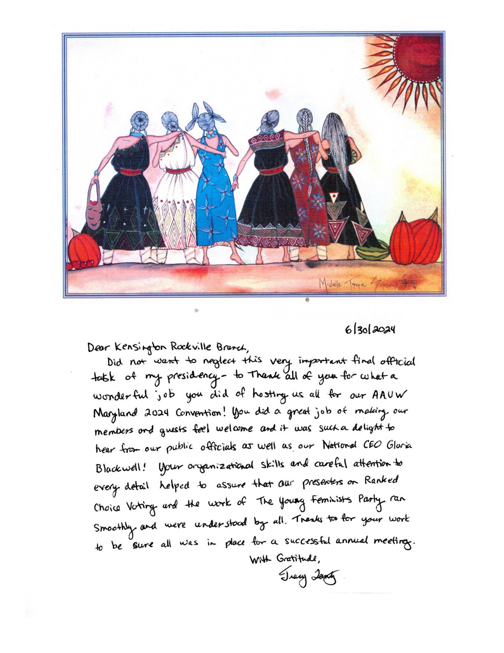

**Proposed 2024-2025 Branch Budget**

|  |  |  |  |  |
| --- | --- | --- | --- | --- |
| **Kensington Rockville AAUW Proposed Budget**  **2024 to 2025** | | | | |
|  | | | | |
|  | **Budget 2023-24** | **Actual   2023-24** | **Proposed 2024-25** |  |
| **INCOME** |  |  |  |  |
| Dues | $560.00 | $512.00 | $560.00 ᴬ |  |
| Donations | $75.00 | $79.00 | $150.00 |  |
| In-Kind Donations | $45.00 | $0.00 | $0.00 |  |
| **TOTAL INCOME** | **$680.00** | **$591.00** | **$710.00** |  |
|  |  |  |  |  |
| **EXPENSES** |  |  |  |  |
| Legislative Briefing | $80.00 | $150.00 | $150.00 |  |
| MD Legislative Agenda | $100.00 | $75.00 | $100.00 |  |
| President | $25.00 | $0.00 | $25.00 |  |
| Membership | $25.00 | $15.28 | $25.00 |  |
| Program & Hospitality | $325.00 | $0.00 | $100.00 |  |
| Yearbook Printing & Mailing | $75.00 | $0.00 | $75.00 |  |
| NCCWSL | $500.00 | $500.00 | $500.00 |  |
| **TOTAL EXPENSES** | **$1,130.00** | **$740.28** | **$975.00ᴮ** |  |
|  |  |  |  |  |
| ᴬ Based on 35 dues paying members.  Honorary Life Members do not pay branch dues.    ᴮAs of 6/30/24, the Branch checking account has $7322.34 thus it seems the Branch can absorb the proposed loss of money for this fiscal year. | | | | |

**Branch Member Remembered:**

Margaret Frostic Schweitzer, an Honorary AAUW Life member and a loyal Branch member since the 1950's, attended her last branch meeting on Saturday, March 16. Three days later she died unexpectedly at Ingleside where she had lived for nearly 15 years. She was president of the Kensington Branch from 1963-65, held numerous other leadership positions at the state level and both Kensington and Kensington/Rockville Branches. A voracious reader, Margaret was part of the Literature Group until last fall. Margaret taught science to middle schoolers in Montgomery County as well as in the District of Columbia and her native Michigan. She was a faithful volunteer for many organizations including Meals on Wheels delivering meals for over 38 years and a driving force leading the Widowed Persons Service. She volunteered in the Smithsonian Botany Department mounting dried plants for display. Before returning to teaching, she was a docent at the National Gallery of Art. Her awards were numerous including the Lifetime Achievement award from the Mental Health Association in 2015 and the Maryland Citizens Hall of Fame award in 2013. She was on the United Way Board and on panels to visit and review organizations' requests for funding. One of her joys was singing in her church’s choirs and the chorus at Ingleside. Margaret was a friend to many and warmly welcomed newcomers to the branch and foreigners who were guests of the federal government. We will miss her. She was 96 and leaves behind 3 children, 6 grandchildren and one great grandchild.

Margaret was my dear friend for more than 60 years. The greatest gift of friendship she gave me was taking over as my campaign treasurer for 12 years. It was stressful, technically difficult, and very tough. I was eternally grateful.

Carol Petzold

**AAUW Atlantic Regional Conference:**

Virginia Crossing Hotel, Glen Allen, VA

September 27-29, 2024

For decades AAUW was divided into ten geographical regions by states. As Middle Atlantic Regional Director, I represented AAUW's national board of directors as a liaison to Delaware, the District of Columbia, Maryland, New Jersey, New York, and Pennsylvania. Sadly, regions were abolished many years ago.

Now, for the first time, state leaders are taking it upon themselves to bring back the practice of bringing together members from a broad area-to reunite with old friends and make new ones, to learn from exceptional leaders and share our own great ideas, to recreate the energy and commitment from numbers that we once felt and now miss.

<https://gcc02.safelinks.protection.outlook.com/?url=https%3A%2F%2Faauwatlanticregionalconference.com%2F&data=05%7C02%7Cmsullivan%40niaid.nih.gov%7C9a7385f8f2c94ab33e8f08dcc47a3530%7C14b77578977342d58507251ca2dc2b06%7C0%7C0%7C638601276354281216%7CUnknown%7CTWFpbGZsb3d8eyJWIjoiMC4wLjAwMDAiLCJQIjoiV2luMzIiLCJBTiI6Ik1haWwiLCJXVCI6Mn0%3D%7C0%7C%7C%7C&sdata=u9tSLF2Hg5q4td1rqCx7i9iF5q8uQ44JIQLoSNAx%2BnE%3D&reserved=0>.

You can register online or by mail. Questions? Email Dian.

Dian Belanger

[dobelanger@comcast.net](mailto:dobelanger@comcast.net)

See attachments.

**Interest Groups**:

**Great Decisions-Live!**

Anita Rosen [anitarosen123@gmail.com](mailto:anitarosen123@gmail.com)

Bobbe Mintz [Bobbeandherb@comcast.net](mailto:Bobbeandherb@comcast.net)

The meeting will be Friday, September 13 at 10:30 in the Derwood Room at Ingleside King Farm. We will be discussing Chapter 7, The High Seas Treaty. The Video will be Thursday, September 12 at 7:00 pm. The URL will be sent prior to the meeting.

**Le Groupe Francais**

Ruth Spivack [raspivack@gmail.com](mailto:raspivack@gmail.com)

The **Le Groupe Français**will meet on Monday, September 16 at 7 p.m. via ZOOM.  The Zoom link will be sent out prior to the meeting.   We will be continuing Moliere's "Le medicine malgre lui."

The Literature Discussion Group

Ella Iams ella.w.iams@gmail.com

The AAUW Kensington Rockville Literature Group will meet on Tuesday,

September 17 at 1:00 - 3:00to discuss The Underground Railroad by

Colson Whitehead. An inventive novel that follows Cora as she escapes

from slavery in Georgia on a literal underground railroad. As she encounters

horror after horror, the story trains an eye on aspects of black history too

often co-opted by white narrators. A work of historical fiction.

Ella Iams will host the meeting. Ella and Howard have recently moved to

Ingelside, so make a note of their new address: 701 King Farm Blvd Apt 427

Rockville, email is unchanged. Please RSVP to ella.w.iams@gmail.com

 CALENDAR OF COMING EVENTS:

27-29 September 2024     Atlantic States AAUW Regional Conference, Glen Allen, Virginia

**Deadline for the next Newsletter is June 20.**

Newsletter Editor Circulation Editor

Margery Sullivan Ruth Spivack

[msullivan@niaid.nih.gov](mailto:msullivan@niaid.nih.gov) [raspivack@gmail.com](mailto:raspivack@gmail.com)

AAUW NATIONAL MISSION: AAUW advances equity for women and girls through advocacy, education, philanthropy, and research. VISION: AAUW will be a powerful advocate and visible leader in equity and education through research, philanthropy, and measurable change in areas impacting the lives of women and girls.

**Kensington-Rockville Branch**

**6540 Wiscasset Rd**

**Bethesda, MD 20816-2113**