**AAUW Kensington-Rockville Branch**

**Ingleside at King Farm - Derwood Room**

**1615 A Piccard Drive or 701 King Farm Boulevard, Rockville**

**Saturday October 19, 2024**

**At 10:30 am**

**October Branch Meeting**

You will be given the opportunity to test your legal intuition! You will be presented with the facts in a legal case. Some cases are actual, some hypothetical, but all will contain conundrums in the law.

No stress. The facts will be understandable and easy to grasp, but difficult to resolve. Led by our member and retired Administrative Law Judge, Bobbe Mintz, our group will try to reach consensus about how best to decide the case.

We will meet in the Derwood Room at Ingleside at King Farm, 10:30am.

Saturday, October 19, 2024.

Optional lunch following in the Courtyard Cafe.

**Presidents' Message**:

President’s Report:

Happy New AAUW Year!

How great it was to see all of you at the opening session for our year 2024-25—longtime friends and new ones too!

By all reports new MLAW executive director Catherine Hill’s presentation on the Maryland Legislative Agenda for Women’s mission, methodology, and accomplishments was enlightening and enticing. That she is not only a public policy professional but also AAUW’s former Vice President for Research made her messaging particularly pertinent for us. And she enthusiastically officially joined Kensington-Rockville Branch on the spot!

Do join us to carpool to the MLAW Fall Conference on November 23rd, where the member organizations will be briefed on priority issues for the upcoming legislative session, to be later voted to a manageable number. Register now to avoid a late fee (after November 10th). Check the MLAW website, [www.mdlegagendaforwomen.org](http://www.mdlegagendaforwomen.org), or just search MLAW and conference information will appear. Email me to share a ride.

I’m delighted to report that we have a new secretary; thank you, Carolyn Dick, for stepping up! We still need a public policy chair and one for philanthropic efforts. We *must*, soon, have a co-president or president-elect!

Special thanks to Joyce Graf and Ella Iams for preparing a budget that we could quickly adopt, and to Yvonne Simms for bringing our snacks and Barbara Gressman for making sure we were prepared for any computer-related need. We missed both of our program vice presidents, who were away, but Anita Rosen’s prior check-ins and suggestions helped smooth the way, as always.

Looking forward to seeing you in October,

Dian Belanger

[dobelanger@comcast.net](mailto:dobelanger@comcast.net)

**“Empowering for Equity,” the Regional Conference Reborn!**

How I wish all of us could have experienced our **AAUW Atlantic Regional Conference**, September 27-29! Held at the old but updated and lovely countryside Virginia Crossings Conference Center near Richmond, we Marylanders reconnected with old friends and met new ones from Connecticut, Delaware, Florida, Georgia, Illinois, Massachusetts, Missouri, New Jersey, New York, North Carolina, Pennsylvania, South Carolina, Virginia, and Washington DC.

Regions were once important divisions of AAUW’s structure. As Middle Atlantic Regional Director, my first and best-loved national board position, I visited state meetings in NY, NJ, PA, DE, MD, and DC to share national news and priorities while learning of their challenges and achievements to inform the national leadership and staff. But several years ago, regions, and thus biennial regional conferences, were abandoned, and we haven’t had a biennial national convention since 2017. We miss one another!

So, last fall, members in the Midwest, led by Missouri, took it upon themselves to organize a highly successful regional meeting (also encompassing states beyond their traditional region). We (I served on the planning committee, along with Tracy Lantz) shamelessly and gratefully borrowed from their programmatic “recipe.” Honored and delighted, they sent four of their leaders to join us (hence the non-seaboard states above).

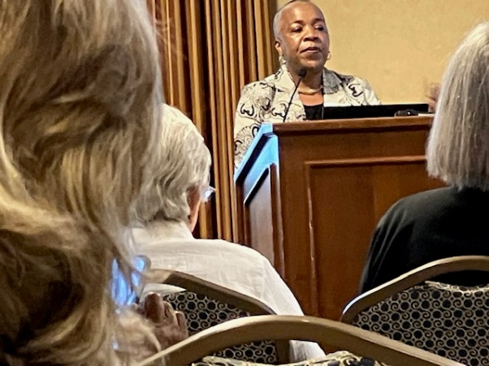Gloria Blackwell, AAUW CEO, led off with an informative and appreciated “Moving AAUW Forward: Priorities, Progress and Potential,” and later addressed our UN commitments and other global engagement. To our surprise she remained with us for two full days. Meghan Kissell, staff VP for Public Policy, also gave enlightening presentations on Title IX in a changing educational landscape and strengthening our advocacy across generations.

National committee members enticed us with their respective contributions to governance, public policy, advancement (fundraising, member growth), and the Capitol Hill Lobby Corps.

Excellent speakers shared their expertise in fields affecting women, such as an immigrant’s legal journey, the evolution of artificial intelligence, the continuing fights for the ERA and reproductive freedom, and the threats to public school teachers and librarians by would-be censors.

We broke into several choose-one-topic-of-four sessions,” during one of which I reviewed, to an appreciative audience, AAUW’s proud, impactful history since 1881. “Swap Shops” featured challenges met, and innovative ideas pursued by branches. I moderated one presented by three engaging Carlisle, PA Branch leaders. “Civics 9-1-1: Constitutional Foundations, Disinformation & Civil Discourse, Civic Engagement & More” was a three-evening program aimed at engaging their community in citizens’ rights and responsibilities.

Our Friday night banquet featured two 2023 NCCWSL attendees, who described their conference participation with hundreds of other college women student leaders with excitement and gratitude that still brings rewards in their continuing educations. A third young woman called her AAUW Career Development grant life changing. We were entertained by seven “Sassy Soulful Sirens,” who beautifully sang of women’s “tales of trial and triumph.”

By Saturday night’s “Dine Around” with others choosing the same nearby restaurant (a cool idea!), we could have talked all night with kindred spirits, now new friends! We’re already discussing another “Regional” two years hence. You won’t do much sleeping. But don’t miss!

Dian Belanger

[dobelanger@comcast.net](mailto:dobelanger@comcast.net)

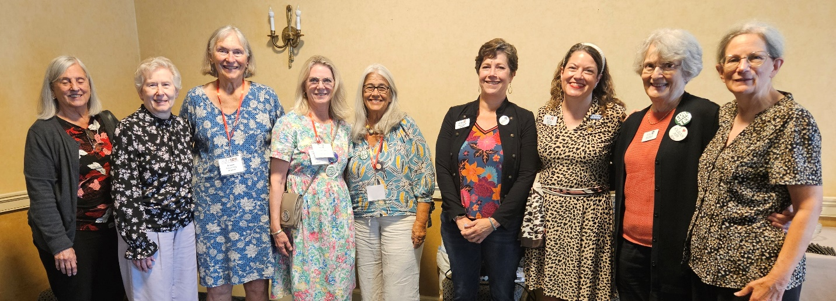

The AAUW Maryland Delegation at the MidAtlantic Regional Conference.

**Interest Groups**:

**Great Decisions-Live!**

Anita Rosen [anitarosen123@gmail.com](mailto:anitarosen123@gmail.com)

Bobbe Mintz [Bobbeandherb@comcast.net](mailto:Bobbeandherb@comcast.net)

What: We will be discussing Chapter 8 Pandemic Preparedness: Ending the Deadly Cycle of Panic and Neglect

Time: Friday, October 10th, 10:30 - 12:00pm.

Place: Derwood Room at Ingleside King Farm. Coffee and drinks available for purchase. Cafe available for lunch or BYOL.

Thursday: October 10 at 7:00 – 7:35. Master Class video on Zoom

Orders will be taken in October for the 2025 Briefing Book. The cost is about $30 and provides thought-provoking analyses of 8 topics of concern to US policymakers and the public today. Our discussions are lively, and we have a video program the night before for added insight. We meet once a month beginning in January. We encourage you to join us.

For further information, contact Anita or Bobbe

**Le Groupe Francais**

Ruth Spivack [raspivack@gmail.com](mailto:raspivack@gmail.com)

The **Le Groupe Français**will meet on Monday, October 21 at 7 p.m. via ZOOM.  The Zoom link will be sent out prior to the meeting.   We will be completing Moliere's "Le medicine malgre lui."

**The Literature Discussion Group**

**Ella Iams** [**ella.w.iams@gmail.com**](mailto:ella.w.iams@gmail.com)

The AAUW Kensington Rockville Literature Group will meet on Tuesday, October 22 1:00 pm to discuss **The Silent Patient** by Alex Michaelides the author combines psychological thriller and detective novel, to reflect upon the impact of childhood trauma, difficulties escaping the past, and the relationship between patient and therapist. The novel centers on psychotherapist and patient in the wake of her husband’s murder.  Unable to speak, the Silent Patient tells her story via her diaries.

Bernie Genovese will host the meeting.  We will be meeting at Bernie’s home in Leisure World.  Let us know you are coming; RSVP to Bernie at [nsjd1@comcast.net](mailto:nsjd1@comcast.net) The meeting begins at 1:00-3:00 pm.

**Calendar of Upcoming Events:**

  MLAW Fall Conference November 23, 2024, [www.mdlegagendaforwomen.org](http://www.mdlegagendaforwomen.org) for details.

**Deadline for the next Newsletter is October 20.**

Newsletter Editor Circulation Editor

Margery Sullivan Ruth Spivack

[msullivan@niaid.nih.gov](mailto:msullivan@niaid.nih.gov) [raspivack@gmail.com](mailto:raspivack@gmail.com)

AAUW NATIONAL MISSION: AAUW advances equity for women and girls through advocacy, education, philanthropy, and research. VISION: AAUW will be a powerful advocate and visible leader in equity and education through research, philanthropy, and measurable change in areas impacting the lives of women and girls.

**Kensington-Rockville Branch**

**6540 Wiscasset Rd**

**Bethesda, MD 20816-2113**