**AAUW Kensington-Rockville Branch**

**Ingleside at King Farm - TBA**

**1615 A Piccard Drive or 701 King Farm Boulevard, Rockville**

**Saturday, March 15, 2025**

**10:30 am**

**March Branch Meeting**

**Understanding the United Nations Commission on the Status of Women**

**Dr. Pat Stocker**

**Pat Stocker, long-time AAUW member, will report on her recent experience as a delegate to the United Nations Commission on the Status of Women (CSW69). She represented Graduate Women International and its US affiliate, Women Graduates USA. She will share the history of CSW and highlights and insights from her participation from 2020 to 2025.**

**The Commission on the Status of Women (CSW) is the principal global intergovernmental body exclusively dedicated to the promotion of gender equality and the empowerment of women. The CSW is instrumental in promoting women’s rights, documenting the reality of women’s lives throughout the world, and shaping global standards on gender equality and the empowerment of women.**

**Dr. Stocker also will share some insights into Women Graduates USA, to learn about what they and how they, as a women-oriented non-profit are responding to changing times?**

Speaker Bio:

Dr. Pat Stocker has spent her lifetime as an advocate for women in both her professional life and her volunteer activities. She has helped corporations and educational organizations broaden the opportunities for women and has been active in organizations advocating for equity for women and girls. Among these organizations is AAUW – the American Association of University Women. She served as president of AAUW Maryland from 2012-2014. She is currently president of the Bethesda/Chevy Chase branch, a position she has held for several years.

She was formerly a marketing professor and associate dean at the Robert

H. Smith School of Business at the University of Maryland at College Park and later served as director of executive education for Marriott International. She has served on numerous of boards including Suburban Hospital in Bethesda Maryland; Common Cause National Board of Directors; The Thirteen professional choir; Maryland Women’s Heritage Center; Graduate Women USA; Interfaith Works; and Bradley Hills Presbyterian Church.

We invite you to join with others for Café lunch on your own us after the program and business meeting.

**President’s Message**:

What a great group we welcomed around our community table in the Derwood Room for February’s member “salon” in February! Thank you, Bobbe Mintz, for organizing and conducting our lively discussion around our educations, aspirations, and life choices. How being a woman “back then,” whenever that was, affected our outcomes drew widespread nods of understanding and empathy. Cheers of congratulations, too! Let’s keep sharing our stories. They’re important—not just to us but among us.

Now we look forward to coming together on March 15th when we’ll learn more about the United Nations Commission on the Status of Women—firsthand, from a CSW delegate. Many of us know Pat Stocker as a leader in both AAUW Maryland and neighboring Bethesda-Chevy Chase Branch. If you do or don’t, you won’t want to miss this opportunity to gain a new perspective on women around the world—what they’re up against, what they’ve achieved.

Here are some of AAUW’s brag-worthy achievements in 2024, our 143rd year as a national organization working for education and equity for women:

* AAUW distributed $6.2 million in fellowships and grants to 285 allowing their pursuit of educational dreams and career aspirations. Since 1888, the year of our first fellowship, AAUW has provided $146 million to nearly 15,000 recipients from 152 countries.
* AAUW continued to offer Work$mart and $tart$mart programs to empower women to negotiate more equitable salaries. (We could do this too—at Montgomery College, or the Universities at Shady Grove!)
* AAUW’s Capitol Hill Lobby Corps visited more than 300 congressional offices this year, even on a reduced schedule. Our reasoned fact-based positions have earned the respect of our lawmakers for half a century. (See Lobby Corps invite below.)

Now, in these days of chaos and overstepping in Washington, we watch hard-won rights chipped, even swept away. It’s ever more important and reassuring to have a long-respected organization to speak for us—and with us. Our voices matter—and matter more when we join them together.

Dian Belanger

[dobelanger@comcast.net](mailto:dobelanger@comcast.net)

Lobby Day in Annapolis

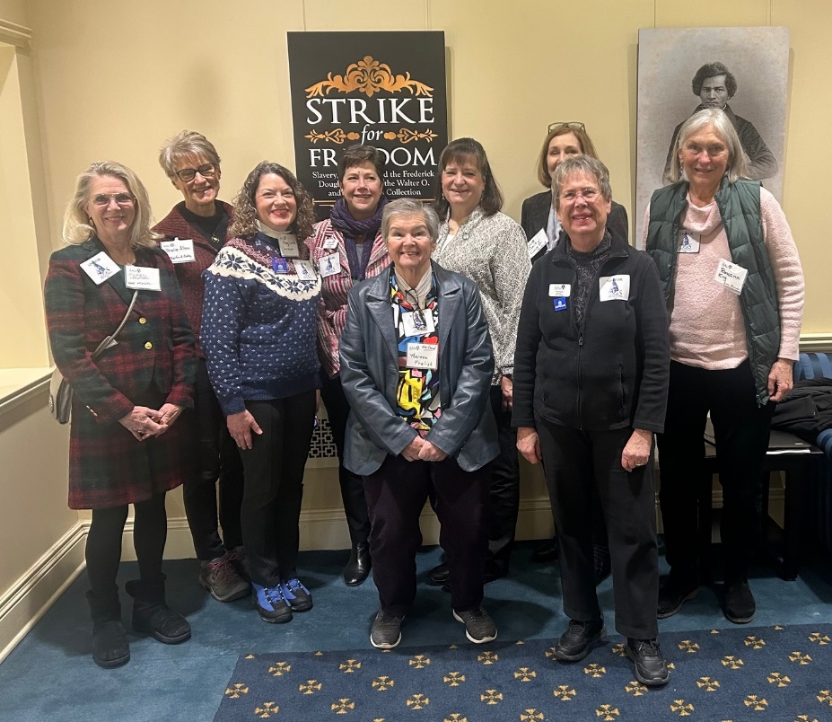

AAUW Lobby Day in Annapolis on February 11, 2025. We visited all the offices of Senate Judicial Proceedings members and House Judiciary members regarding four bills. two were related women in prison and two were related to women’s protection in cases of abuse. Two members of Kensington- Rockville attended, Tracy Lantz and Anita Rosen. The picture was taken in the Lowe House of Delegates Office Building. L-R Susan Crawford, Sheila Allen, Tracy Lantz, Heather Reichardt, Theresa Freligh, Judy Carbone, Cathy Lovett, Anita Rosen, Roxann King. Other branches represented included Garrett, Anne Arundel, Harford, and Gaithersb

**The AAUW Archives Corps Invites You!**

Do you enjoy discovering hidden treasures? Are you curious about AAUW’s amazing past? Would you like to make a significant contribution with no ongoing advance preparing?

If so, please join the fun, with other dedicated member volunteers from the DMV area who comprise the AAUW Archives Corps. We meet on the 4th Monday of alternate months at our national office at 1310 L Street NW, Washington, DC, 10:00a-2:00p.

Training and ongoing guidance are provided so we can confidently process and preserve our historic past. Our important efforts make these records usable and accessible to present and future researchers.

Yes, much of what we do is scut work: remove staples, arrange papers chronologically (or in other logical sequence), cull duplicates, transfer the organized documents to acid-free folders. But what a thrill it is to uncover an awesome, unusual, funny, or long forgotten missing link. My favorite finds so far: A member/leader bequeathed a Montana gold mine to AAUW in the 1970s! (Then what? Still searching . . ..)

Bring or buy your lunch nearby. There’s a parking garage adjacent; or it’s about a five-block walk from the Farragut North or Metro Center Metro.

Questions? Ready to sign up?

Please contact Dian Belanger

[dobelanger@comcast.net](mailto:dobelanger@comcast.net)

**The AAUW Capitol Hill Lobby Corps Seeks You!**

Do you care if the now-fully approved **Equal Rights Amendment** gets added to the Constitution as the 28th Amendment?

Is it right that over half a century after **pay discrimination** became illegal in the United States, women working full time are still paid 83 cents for every dollar earned by men?

Why are we last among developed nations to provide **paid family and medical leave** for all?

If you are feeling called to *do* something positive in these challenging times, do consider joining the AAUW Lobby Corps, which has actively advocated on Capitol Hill since 1975. Member volunteers, well trained and briefed by AAUW public policy staff, visit assigned congressional offices, in pairs, to promote nonpartisan progress toward a more just nation. Training lately has been virtual, with in-person briefings in the appropriate House or Senate cafeteria prior to the day’s visits. Written position papers and talking points are emailed in advance. It’s easy. It’s truly rewarding—well, sometimes frustrating. It always matters.

The Lobby Corps currently works only one morning per month when Congress is session—usually on the 3rd Thursday but individual dates may vary if needed.

Dian Be

**Interest Groups**:

**Le Groupe Francais**

Ruth Spivack [raspivack@gmail.com](mailto:raspivack@gmail.com)

The **Le Groupe Français**will meet on Monday, March 17 at 7 p.m. via ZOOM.  The Zoom link will be sent out prior to the meeting.   We will continue the novella, “Carmen” by Prospere Merrimee.

**The Literature Discussion Group**

**Ella Iams** [**ella.w.iams@gmail.com**](mailto:ella.w.iams@gmail.com)

The AAUW Kensington Rockville Literature Group will meet on Tuesday, March 18 at the home of Bernice Genovese, 15000 Pennfield Circle, Unit 108, Silver Spring, in Leisure World. The meeting time is 1:00-3:00 pm. Drinks and light refreshments provided. Please RSVP to [nsjd1@comcast.net](mailto:nsjd1@comcast.net)

The March selection is **The Heaven and Earth Grocery Store** by James McBride.

A murder mystery is woven into the fabric a novel about community. Discovery of a skeleton in a well sets off a narrative that explores the secrets of Chicken Hill, a rundown neighborhood where African Americans and immigrant Jews live together, sharing both hopes and tragedies in Pottstown, PA. Chona Ludlow manages the Heaven & Earth Grocery Store, while husband Moshe operates a theater. The author creates memorable characters, delving into their lives and the broader community.

The April selection is **An Unfinished Love Story**: a personal history of the 1960s by Doris Kearns Goodwin- 480 pp

This book provides a look at the. 1960s and key players through the lens of Doris, a historian, and her late husband Dick, a speech writer for Presidents and political leaders.

**Great Decisions-Live!**

Anita Rosen [anitarosen123@gmail.com](mailto:anitarosen123@gmail.com)

Bobbe Mintz [Bobbeandherb@comcast.net](mailto:Bobbeandherb@comcast.net)

What: Chapter 3: Competition, Cold War, or Conflict? Navigating U.S.-China Relations in Tense Times

When:  Friday, March 28 10:00 am-11:30 am.

Where:  Ingleside at King Farm, Derwood Room (map attached)

Coffee and light snacks are available for purchase

Please feel free to join in with others for lunch at the Cafe after the discussion.

A ZOOM URL will be sent to view the Master Class Video for Chapter 3 for March 27.

**Calendar of Upcoming Events:**

**AAUW MD State Convention April 26, 2025, Gaithersburg**

.

**Deadline for the next Newsletter is March 20.**

Newsletter Editor Circulation Editor

Margery Sullivan Ruth Spivack

[msullivan@niaid.nih.gov](mailto:msullivan@niaid.nih.gov) [raspivack@gmail.com](mailto:raspivack@gmail.com)

AAUW NATIONAL MISSION: AAUW advances equity for women and girls through advocacy, education, philanthropy, and research. VISION: AAUW will be a powerful advocate and visible leader in equity and education through research, philanthropy, and measurable change in areas impacting the lives of women and girls.

**Kensington-Rockville Branch**

**6540 Wiscasset Rd**

**Bethesda, MD 20816-2113**